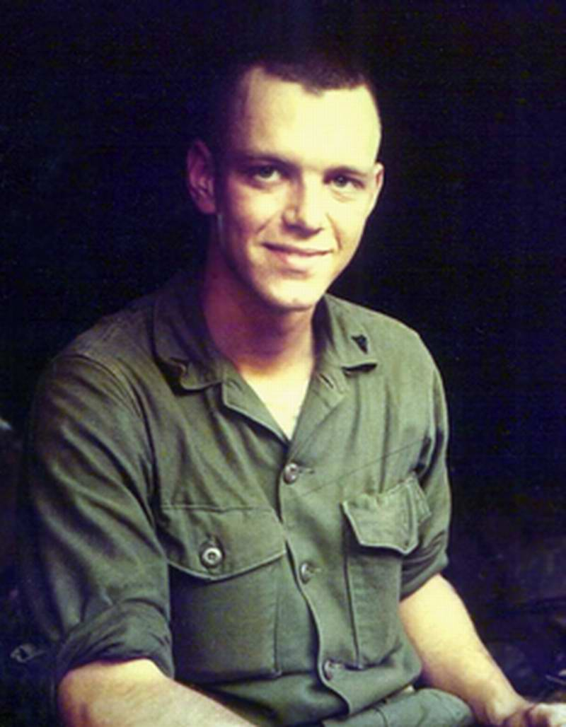

Sgt. William Thompson Rogers

KIA 03/06/68

I have been in touch with Jim Furlow recently and just read his entry under March 6, 1968.

The "Sgt. Bill Rogers" he referred to in the last paragraph was my brother. We called him "Tom".

Tom was the epitome of the big brother. I looked up to him as a brother and a Marine. I was only ten years old the night Major Vreland and another Marine came to our home to give us the news, but I knew immediately why they were there.

Later, Sgt. Ron Campbell from New Jersey came and stayed a week with my family. We've lost touch but I hope he's doing well.

Marc Rogers

